EXPERIMENT 4

PROGRAM USING CONTROL STATEMENT

REVERSE PYRAMID:

PROGRAM:

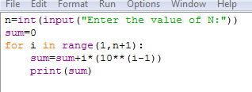

OUTOUT:

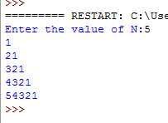

LEAP YEAR BETWEEN 1900-2000:

PROGRAM:

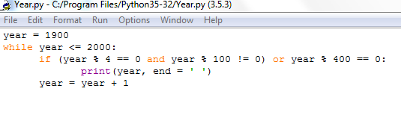

OUTPUT:



RIGHT STAR PATTERN OF STAR:

PROGRAM:

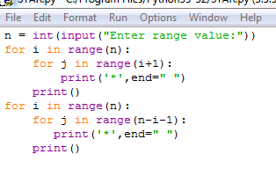

OUTPUT:

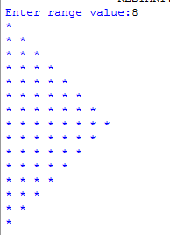

NUMBER SERIES:

(a)PROGRAM:

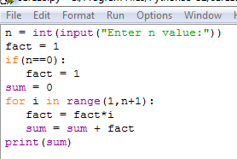

OUTPUT:

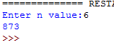

(b)PROGRAM:

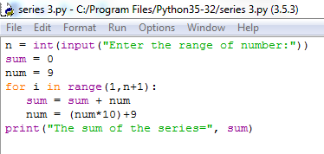

OUTPUT:

